Introduction

* The main purpose of the project is to design and maintain a website which consists of home page, login page and contact us page regarding the retro cars.
* The project is based on retro cars website which can be accessed locally.

Home page

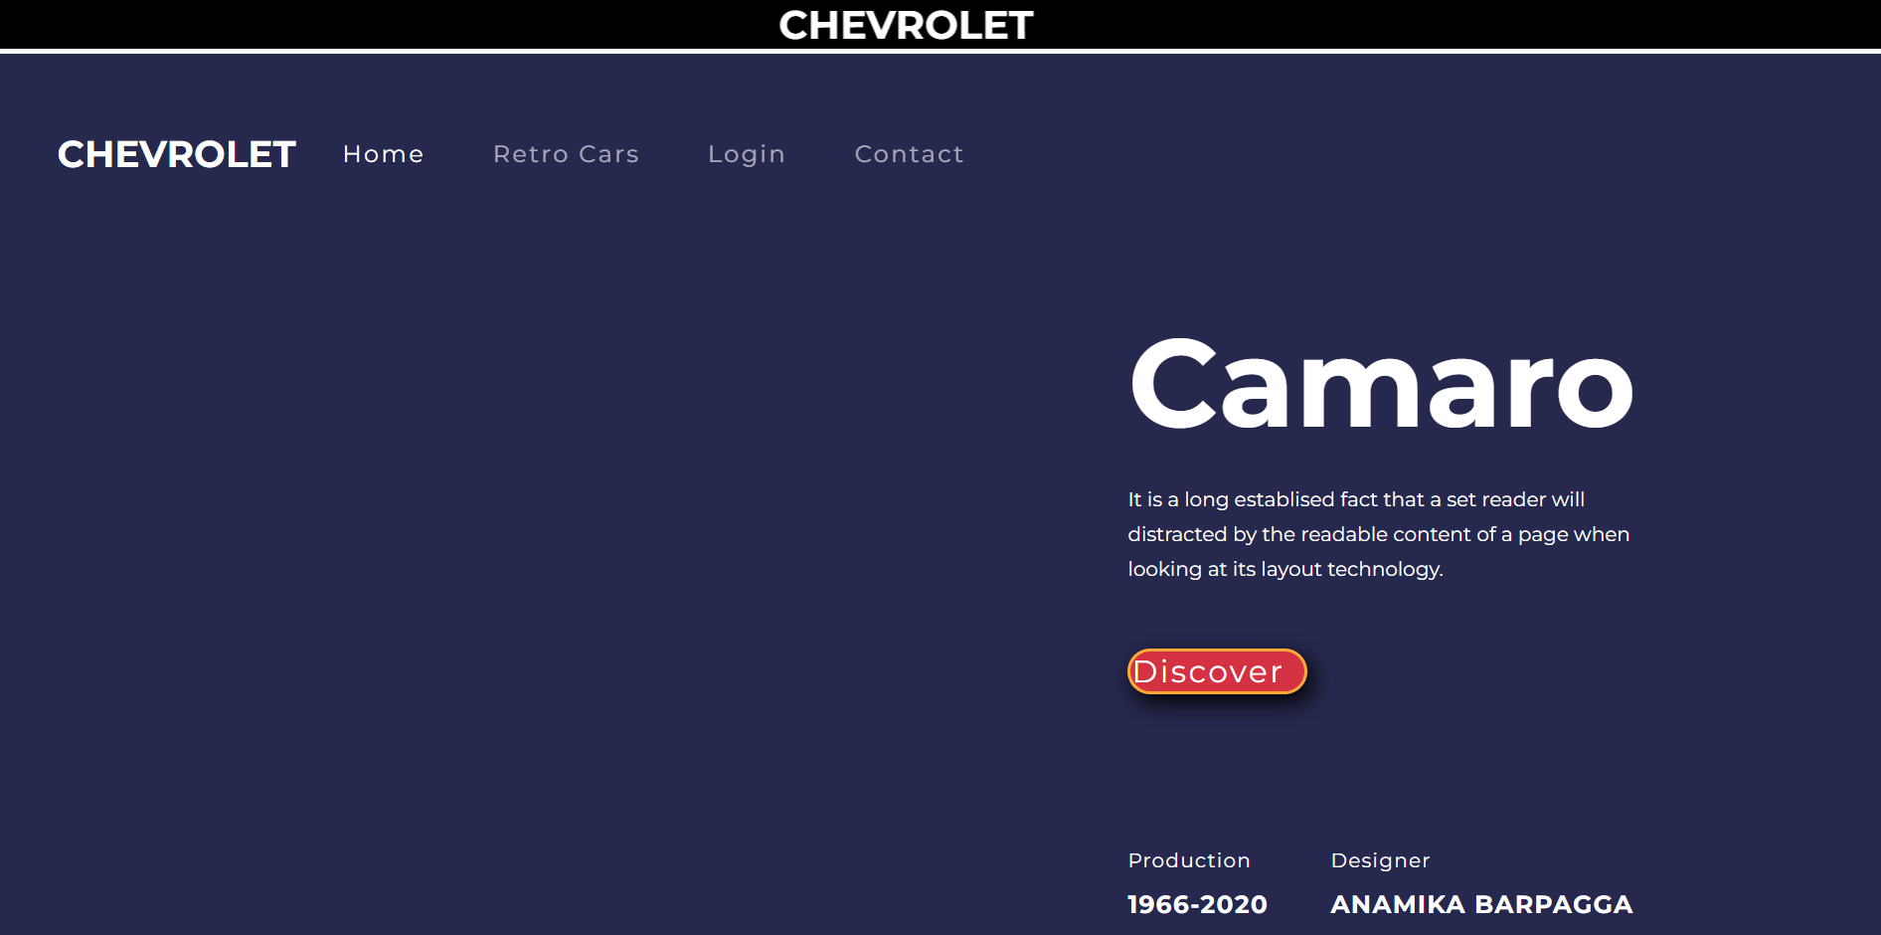

* The <meta> tag defines metadata about an html document.
* The <href> tag is used to link the current document to another document.
* The <script> src attribute is used when we want to run the same JavaScript on several pages in a web site, we create an external JavaScript file, instead of writing the same script over and over again and then save the script file with a .js extension, and then refer to it using the src attribute in the <script>  tag.
* The <div> tag is used as a container for HTML elements - which is then styled with CSS or manipulated with JavaScript.
* The <marquee> HTML element is used to insert a scrolling area of text.

Login page



* The <div> tag is used as a container for HTML elements - which is then styled with CSS or manipulated with JavaScript.
* The <label> tag is used to tell users the value that should be entered in the associated input field.

Contact us page

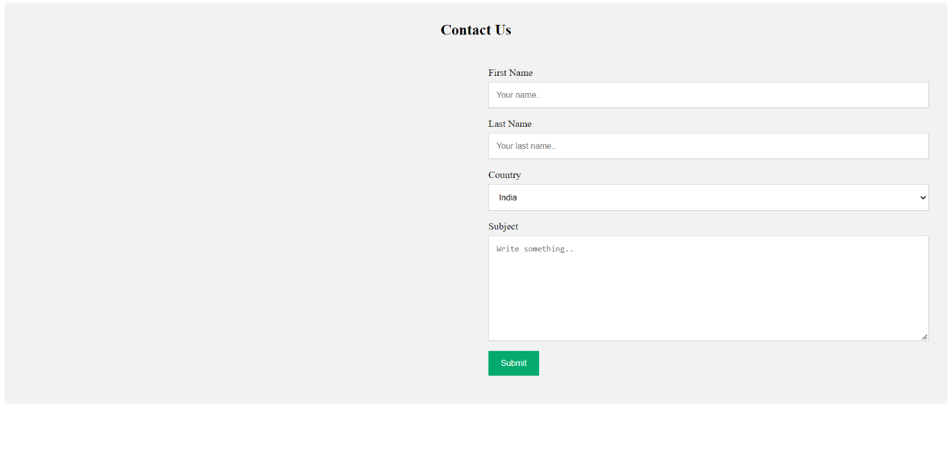

* The <select> tag is used to create a drop-down list. The <select> tag is most often used in a form, to collect user input.
* The <span> tag is used to group elements for styling purposes using the class or id attributes.

https://github.com/Anamika-Barpagga/CSE-Project.git